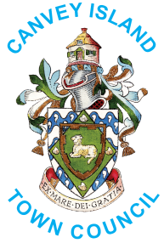

King’s Coronation – Design A Crown

COMPETITION ENTRY FORM

Please complete the following in block capitals as follows:

Name and School Name: ...……………………………………………………..……........................................

...………............……………………………………………..…….........................................................

Please give a description of your Crown

...……………………………………………………..……........................................................................
...……………………………………………………..……........................................................................
...……………………………………………………..……........................................................................
...……………………………………………………..……........................................................................
...……………………………………………………..……........................................................................

Why should your crown win?

...……………………………………………………..……........................................................................
...……………………………………………………..……........................................................................
...……………………………………………………..……........................................................................
...……………………………………………………..……........................................................................
...……………………………………………………..……........................................................................

Judging will take place the week commencing 1st May 2023, please submit your crown drawing or photograph by Friday 28th April, this can be done via email events@canveyisland-tc.gov.uk, by post, or by whatsapp (please arrange with Mrs L. Gould)

The winning entry will be photographed and a press release issued to the local press. Please sign this form to say that if chosen, you would agree to take part in the publicity.

Signature: …………………………................................Date: ………………...................……..........…

Thank you for entering our Canvey Island King’s Coronation Design a Crown Competition.
Good luck with your entry.

Please return your completed form by
Friday, 28th April 2023
to the Town Council office at 11 High Street, Canvey Island, SS8 7RB or events@canveyisland-tc.gov.uk

